Table of Contents
1. Analysis (10 Marks) 3
Problem Identification, Aims and Objectives 3
Aims 3
Objectives 3
Computational Methods 3
Stakeholders 4
Existing Product Research 4
Essential Features 4
Limitations 4
Hardware and Software Requirements 4
Success Criteria 4
Report overview 5
2. Design (15 Marks) 6
Decompose the Problem 6
Describe the Solution 6
Approach to Testing 8
3. Development (25 marks) 9
Iterative Development Process 9
Testing to Inform Development 10
Evidence and Refection 10
4. Evaluation (20 Marks) 11
Testing to Inform Evaluation 12
Success of the Solution 12
Describe the Final Product 13
Maintenance and Development 13
Related Work 13
5. Conclusion 15
Reflection 15
Future Work 15
6. References 16
7. Appendices 17
1. Analysis
Project Definition:
I am going to create an application for computers that assists people who do the sport of bouldering, by tracking how much they improve at it and create a competitive component to the sport by adding a leaderboard to track people’s progress and display who the best users of the app are. In order to do this I am going to use python, as it is the programming language that I am the most familiar with. I will also import some libraries into python, such as ttkbootstrap, to allow me to create a graphical user interface.
Bouldering is a form of rock climbing, a sport where the goal of the athlete is to reach the top of a wall or rock that they are climbing. However, what separates it from normal rock climbing is that rather than walls or cliffs that are up to 15 metres tall, bouldering focuses on short, more technically and physically challenging climbs, where the walls are between 3 to 4.5 metres. In my opinion, this means bouldering is typically more exciting than traditional rock climbing, which is a lot less fast paced. Bouldering is also more accessible than traditional rock climbing, as no harness is required as it takes place over a soft mat to catch climbers if they fall. This means that the only equipment required are shoes. Bouldering can take place indoors on manufactured walls, or outdoors on literal boulders made of rock. Each individual climb has its own difficulty rating, so by tracking this difficulty rating, my app will be able to work for both indoor and outdoor climbers.
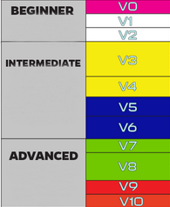
These are the difficulty ratings for different climbs. My app will reward users for completing climbs by giving them points on the leaderboard, with harder climbs giving more points. My app will also track how many attempts it takes to complete each climb, as this means it can show the user’s progress without them having to do a more difficult climb every time. The more attempts that a climb takes, the less points will be gained for completing that climb.

Aims
My aim is to encourage more people to go climbing more often, by providing an app which will motivate them to compete with their friends by having a leaderboard so they can compare their skill. It will also track their progress and display it in a useful way, such as a graph, so that users do not lose motivation and feel like they’re not improving, as they will have a constant reminder that they are. This will mean that they will be healthier, as they will get more exercise.

Target Users
My application will be targeted towards people who climb casually, rather than at a professional level . This includes people who are new to climbing, and people who climb occasionally (e.g. once a week), who enjoy the sport and would like the motivation to continue doing it. This is because climbers who compete at a high level have lots of opportunities to demonstrate their skill in tournaments, meaning they have the motivation to climb as much as possible, and are able to track their progression based off their performance in tournaments. In comparison, people who are not skilled enough to compete in tournaments will be able to use my app to compete against people of their own skill level. This will help people who are new to climbing, as well as people who climb for fun, as they will have motivation to get more practice.

Stakeholders
Other stakeholders include people who own bouldering gyms, as if people who have the app go climbing more often, the owners of the gyms will get more business. People who don’t boulder but have friends who do could also be stakeholders, as they will be encouraged to compete with their friends by the app, so might start climbing.

Survey
Because most of the users of the app will be people who are new to climbing or don’t go climbing very often, I am going to survey the people who I know have been bouldering before to find out how often they go. Then I am going to do a questionnaire to find out what those people would want out of a bouldering app.

Results
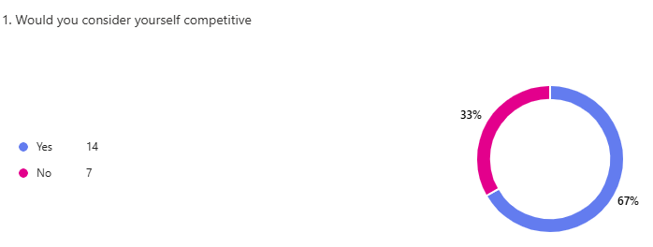
Most of the people who I surveyed said that they would consider themselves competitive people. This means that they are likely to be more motivated to do something (e.g. bouldering) if it was competitive.
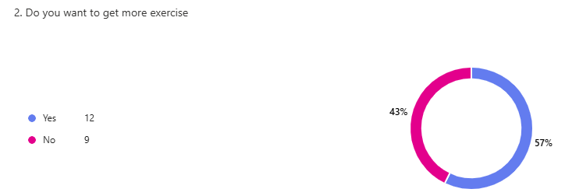
More than half of the people who I surveyed also said that they would like to get more exercise, as they are not satisfied with the amount that they currently get.
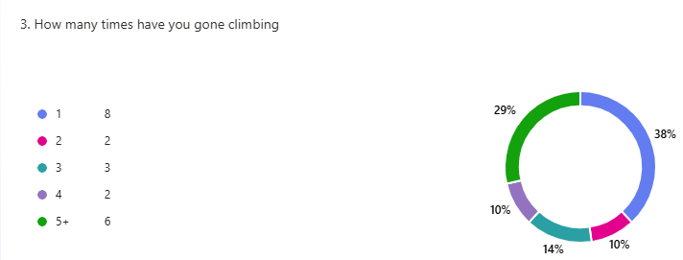
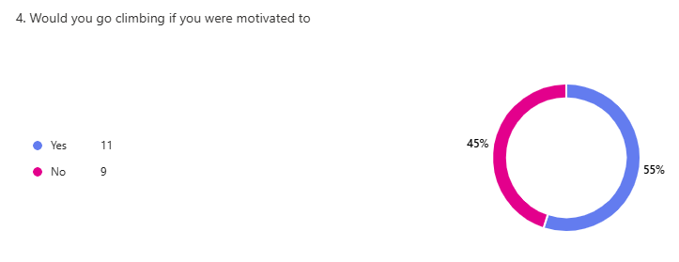
I

I interviewed a range of people of different experience levels, however most of them had been climbing at least three times, but a lot had only gone once or twice. However, the majority of them said that they would go climbing if they were given more motivation.
This data shows that while most of the people who I interviewed enjoy climbing, and would like to get more exercise, most don’t. However, they also said that they were comp

Computational Methods
- Abstraction – my app needs to be useful at all climbing gyms, so it will not include information about specific c, as most gyms create new climbs every week, so instead of tracking the exact details of every climb, such as what gym it takes place,
- Decomposition – I will create the system that creates the leaderboard, the system that creates the graphs and the system that inputs data into the database separately.
- Algorithmic thinking – Because a lot of calculations will be involved, algorithms will be used to do them very quickly and without making mistakes

Why a computerised solution is best

- Another way of doing what my app intends to do but without a computer is to create a spreadsheet on paper, however this would mean that it would be significantly more difficult to compile data from multiple users. A computerised solution would mean that the computer’s file system could be used to collect data from users (specifically what climbs they did and how many attempts it took them), from the device.

Existing Product Research
There are two main software at the moment that can be used to track progress when climbing: Kaya and Redpoint. However, both have issues that I plan to address with my product.
Both of these products are incredibly highly monetized, meaning that redpoint requires a monthly subscription. Likewise, Kaya has a monthly subscription, or a free tier of access, however this bombards the user with advertisements, which multiple users have complained about.
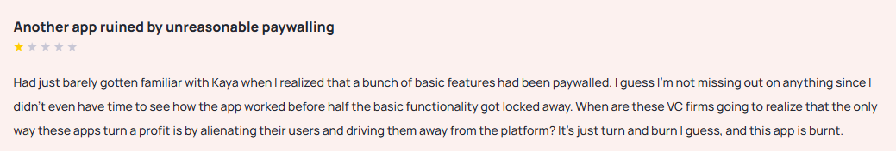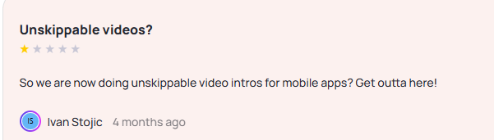
Both apps also have reviews complaining about the slow and confusing user interface:
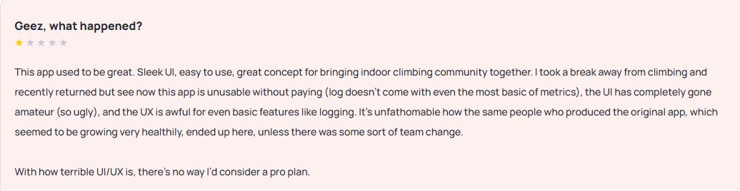
Some users have also complained about the app crashing frequently, and containing lots of bugs in general: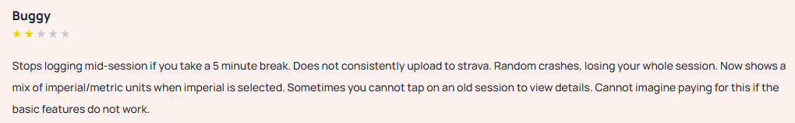
summary here

Second Survey
After finding out what was wrong with other options for tracking progress, I decided to conduct an interview with someone who I know who goes climbing regularly.
functional requirements
- The system must allow users to register and log in securely.
- The system must be able to be accessed from mobile devices
- The system must save user data, even when the program is not running
non-functional requirements
- The system should be able to load in under two seconds
- The system should be able to create graphs
- The system should be able to sort data items

Limitations
It has to be run on a mobile device, so the hardware it is used on might not be very powerful, so I will not be able to perform any hardware intensive operations. Also, as the app will only be developed by one person, in a limited amount of time, it is possible that not all objectives will be completed in the time frame.

Hardware and Software Requirements
The device will need to be able to at the minimum, run a browser like google chrome, and python, which requires 2GB+ of RAM and at least 4GB of storage.

Success Criteria
- A user should be able to view the leaderboard, and sort it according to multiple different variables.
This will have been achieved if the leaderboard is stored in a spreadsheet file that can be seen on the user interface.
- A user should be able to view a graph showing all of the climbs they have done.
This will have been achieved if the user is able to see a visual representation of their progress that is easy to understand (e.g. a bar chart showing how many climbs of each difficulty they have done)
- A user should be able to record what climbs they did and view them at a later date
This will be successful if the user interface is able to display the date a climb was completed, what difficulty it was and how many attempts it took. This could be achieved using an SQL database.
- The user should be able to create and sign into a unique account, allowing them to be placed onto the leaderboard. This will be achieved if the password and username are stored and can be compared to what is input when signing in. If the username and password match the user should be allowed to sign in, otherwise they should not be allowed to sign in.

2. Design
As I have now completed the analysis of the problem that my program aims to solve, I am now able to start to decompose the problem and plan out what I am going to have to make.

In order to organise this, I have created a top-down diagram.
Decomposing the Problem
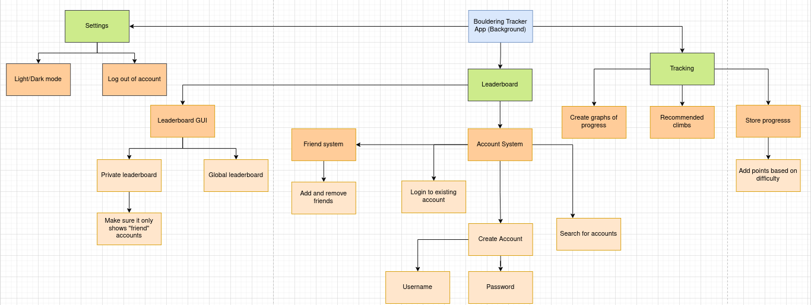

My app will have two main components, as well as a settings page, which are highlighted in green on the diagram; the leaderboard, and the personal tracking sections.

The leaderboard section will be made up of a global leaderboard and a private leaderboard. In order for the two leaderboards to work there must be a system that allows users of the application to be identified by an account with a unique username.

This means that users must be able to create accounts and then log into them once they have been made. For this to work the user must be presented with the option to choose whether or not they want to create an account or log into an existing account. If they choose to create an account, they must input a username and then a password. The program will then check if the username is already assigned to a user and prompt the user to enter a new one if it is, and store it if it is not. If the user chooses to log into an existing account instead, the program will check if the password they have input matches the username, and if it does the main application will open.

Once the user is in the main application, they will be able to view their own, as well as other people’s statistics, on either the leaderboard, or by searching for their name in the “search usernames tab”. Because each user can be identified by the program through the account system, the current user is able to choose which accounts will be shown on the private leaderboard by adding them to their “friends list”, which can be stored as a file on the computer.

The other main component of the application will be the tracking, which will allow the user to input climbs after one has been completed. This will require the application to be able to store a user’s climbs so that they can view how many climbs of each difficulty they have completed, as well as other interesting statistics. As well as storing the climbs, the system will also have to store the points earned from each climb, which can be stored in a csv file with their other account details, like their username. This will have to be updated every time a new climb is completed.

The system will also need to be able to read from the files, so that it can use an algorithm to calculate what climb a user should do next. This will require the program to know what difficulty of climbs have been done recently, as well as how many have been done, which it can read from a csv file.

The other main component is the settings tab, which will need to check a file every time the application is opened, so that the correct settings apply. This file will then have to be edited, so that it can save any changes that can be made.

User Interface Design
I would like to make my app use a blue and white colour scheme, however this may change to a more monochrome design if I decide that that looks better during development. There will also be an option to change the theme to a dark mode if the user would prefer that. The app will have 5 main tabs, each with a different component, making it easier for users to locate the feature they would like to use.
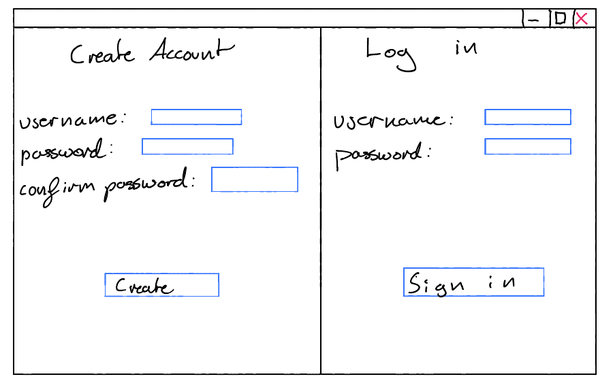
1. This is the first thing that a user will see upon opening the application. In order to make it simple to tell whether they are signing into an account or creating an account, they will be presented with both options simultaneously, rather than having a button to switch between them. It will also be very obvious where they should input their username/password, as it will be labelled. I will also make them confirm their password, so they don’t accidentally write the incorrect password.
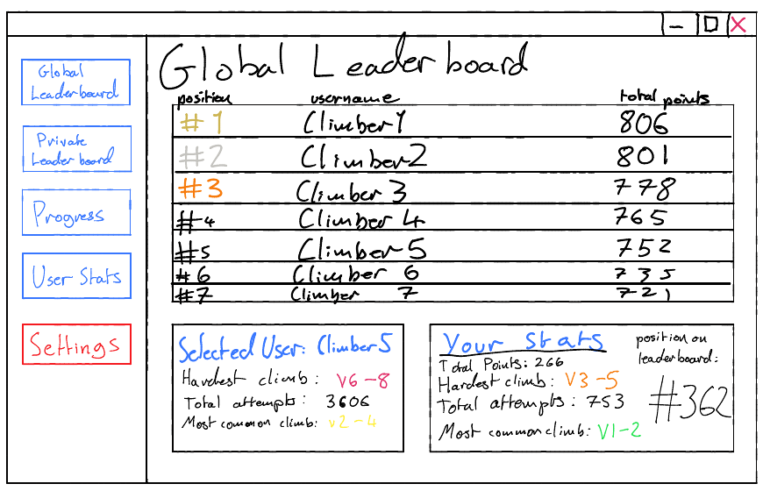
2. After signing in, the user will see the “global leaderboard” tab, which will show every single user on the app in a list, sorted by points in a descending order. The user will be able to scroll through this list to see more users, and the number of points that someone on the leaderboard has will be shown on the right of their username, and a small box with some statistics below the leaderboard will show a summary the current user’s statistics. Next to it the same thing will be shown for a user on the leaderboard, and this one can be changed by the user clicking a name on the leaderboard. This makes it easy for the user to compare their own statistics to other people’s statistics. I think this will make it easier for climbers to compare themselves to the people who are doing the best in the leaderboard, which will inspire them to try and get to the top, and also show them what sort of climbs they should be doing to get there. In the box showing the current user’s statistics, their position on the leaderboard will be shown so that it is easy to find where they are on the leaderboard, and who is nearby.
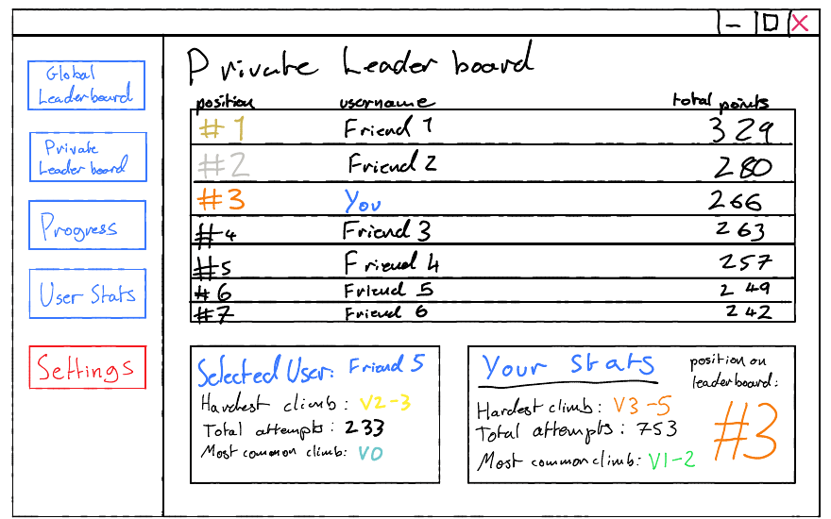
3. The “private leaderboard” tab will be exactly the same as the public leaderboard, making it easy to navigate as users will already be familiar with it. The only difference is that the users on the leaderboard will only be accounts that the logged in user has friended. In order to avoid confusion with the public leaderboard, there will be a large header at the top to show that this is specifically the private leaderboard.
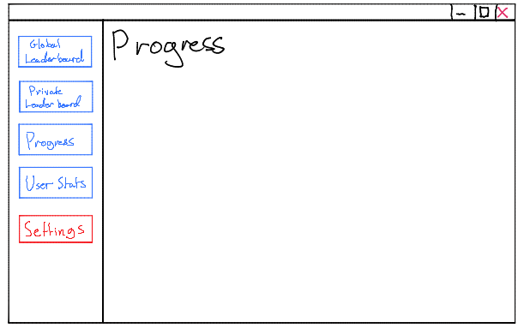
4. The “progress” tab will be used to show the user’s personal statistics more in-depth than is shown on the leaderboard. It will do this in the form of graphs, making the progression of each user more visual. It will also allow them to log any climbs that they have completed. Additionally, it will suggest what climb a user should do, based on whether they want to warm up, or are feeling confident and would like to go for a more challenging climb.
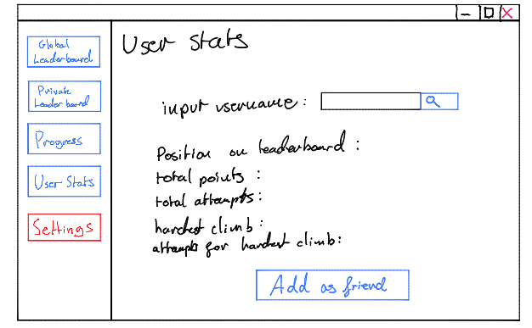
5. The “user stats” tab will let users search for a specific player using their user name. This will allow them to view their statistics and add them as a friend.
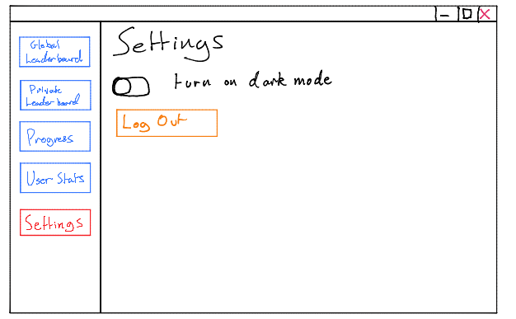
6. The “settings” tab will be where the user can customise their account. I will add more content to this page as I continue programming the application.

Processes
Points System:
- When a user completes a climb they will be rewarded points, so to reward players for attempting more challenging climbs, they will receive more points for a climb of a harder difficulty
Pseudocode:
#accountStats is a 2D array where some of the data is stored
#pointsDictonary is a dictionary that converts the data into
#function to add points to a user
def addPoints(difficulty, username):
for i in range(0, len(accountStats)):
if accountStats[i][0] == username:
accountStats[i][1] = accountStats[i][1] + pointsDictionary[difficulty]
Account System:
Users will be able to create an account or log into an account when the app is opened
- If they want to create an account they will put in the username they want and the password they want to use.
  - The username must be less than 20 characters, and not have any spaces.
  - The username must be unique
  - The password must be at least 6 characters and have numbers, letters and special characters.
  - If all of these requirements are met, the account will be created and stored in a file on the computer and the user will be sent to the main menu of the app, otherwise the user will be prompted to fix whatever is incorrect.
- If they want to log into an existing account, they will have to put in their username and password.
  - The program will check these against the file with usernames and passwords.
  - If an account with that username exists, and the password entered by the user matches the one linked to that account, the user will be sent into the main menu of the app.
  - Otherwise, the user will receive an error message telling them why they were not allowed in (e.g. “incorrect password” or “user does not exist”)

Pseudocode:
#function to create an account
def createAccount(username, password):
if checkIfExists(username) == False And checkIfStrong(Password) == True:
accounts.append(username, password)
#function to check if a username exists
def checkIfExists(username):
for i in range(0, len(accounts)):
if accounts[i][0] == True:
return True
return False
#function to check if a password is strong
specialChars = [“!”, “@”, “#”, “$”, “%”, “&”, “?”, “£”]
def checkIfStrong(password):
if len(password) >= 6 And len(password) <=20:
for i in password:
for j in specialChars:
if i == j:
return True
return False
return False
#function to sign into an account
def login(username, password):
for i in range(0, len(accounts)):
if username == accounts[i][0] And password == accounts[i][1]:
return True
return False

Friend system:
- If a user adds another user as a friend, the other user will receive a friend request the next time they log into their account. If this is accepted, the accounts will be saved onto a file as friends.
- When the user opens the private leaderboard, instead of searching through every user to find accounts to put on it, only the users who are saved as friends will be shown.
- Users will also be able to remove friends if they were added by accident.
Leaderboard system:
- The program will apply a sorting algorithm to the table with all of the user data to sort it by the number of points that each user has.
- This will then be stored as an array in the memory so that it can be written onto the leaderboard.
Pseudocode:
#function to sort array by points
def sort2D(array)
array = sortedArray
for i in range(len(array)-1):
for j in range(len(array)-1-i):
if int(sortedArray[j][1]) < int(sortedArray[j+1][1]):
sortedArray[j], sortedArray[j+1] = sortedArray[j+1], sortedArray[j]
return sortedArray

Tracking system:
- Using the points system, when a user completes a climb, they can receive points which not only will be used to calculate their place on the leaderboard, but will also be used to calculate their progress and to recommend their next climb
- When a user is on the “progress” tab of the app, they will be able to choose a preference for their next recommended climb:
  - [Warm-up] → (average difficulty) DIV 2
  - [Average] → (average difficulty)
  - [Difficult] → (average of top 20% of climbs, or hardest climb or one above hardest climb, depending on distribution of climbs)
- When a climb is logged, the program will add the number of points gained and attempts it took to the total, then replaces the old values with the new values in the file.
- It will also have a graph that has time on the x axis and hardest climb on the y axis, to show the user’s progression.

Pseudocode:
#function to sort calculate next climb
def nextClimb(mode, username):
pointsListKeys = list(pointsDictionary.keys())
for i in range (0, len(accountStats)):
if username == accountStats[i][0]:
mostCommonClimb = accountStats[4]
#return a climb that is half the difficulty of the most common climb
if mode == “warm up” or mode == “warm down”:
for i in range(0, len(pointsListKeys)):
if pointsListKeys[i] = mostCommonClimb:
return pointsDictionary[pointsListKeys[i//2]]
#return the most common climb
if mode == “normal”:
return mostCommonClimb
#return a climb that is slightly more difficult than usual
if mode == “difficult”:
for i in range(0, len(pointsListKeys)):
if pointsListKeys[i] = mostCommonClimb:
return pointsDictionary[pointsListKeys[(i*1.3)//1]]

Variables
username
- The username of an account
- string
password
- The password of an account
- string
totalPoints
- The total number of points a given user has
- integer
hardestClimb
- The difficulty rating of the hardest climb that a user has completed
- string
totalAttempts
- The total number of attempts a user has across all climbs
- integer
mostCommonClimb
- the climb that a user has done the most often
- string
date
- The date that a new hardest climb was completed
- date

Database
In order to store the user’s data efficiently, I will use a relational database. Each table will be a .pkl file with the primary key that links them being the username of each user because these will be unique. I am planning to use the “pickle” library to store my data because it is relatively easy to use and I have used it before.
In order to make writing the code easier I have made a relationship diagram to show what data is stored where. Every data structure mentioned below will be a .pkl file, as pickle allows you to dump and load data structures directly, unlike .csv and .txt, which require functions to write data into them. Because of this, after certain actions, like adding points or creating an account, the data will be saved using a save procedure, which will gather all of the necessary data structures and save them into their respective files.
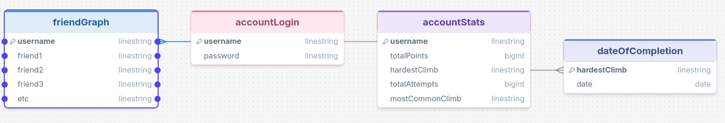
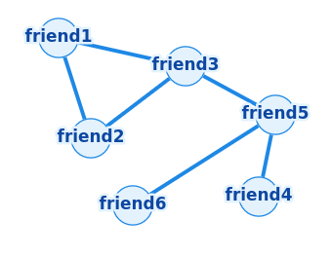
The friend graph will be a bi-directional graph that links every account with each other if they are friends. This will make it easy to tell who is friends with who, and make it more space efficient. For example:

Data structures
The account login will be created as a 2D array because this will mean its easy to search for both the username, and the password. It will look like this:
accounts = [[username1, password1], [username2, password2], [username3, password3]]

accountStats will also be stored in a 2D array, as it will be simpler to sort like this. It will be formatted like this:
[[username1, totalPoints1, hardestClimb1, total attempts1, mostCommonClimb1], [username2, totalPoints2, hardestClimb2, total attempts2, mostCommonClimb2]]

As well as those two, dateOfCompletion will also be stored in a 2D array, like this:
[[username, hardest1, date1, hardest2, date2, hardest3, date3], [username, hardest1, date1, hardest2, date2, hardest3, date3]]
each array within dateOfCompletion will be assigned to an individual account, and every time they complete a new hardest climb it will be appended onto their array, along with the date when it happened.

There will also be a dictionary to assign a value to each of the difficulties of climbs. It will look like this:
pointsDictionary = {
“V0”: 1,
“V1-2”: 2,
“V2-3”: 5,
“V2-4”: 10,
“V3-5”: 25,
“V4-6”: 35,
“V6-8”: 50,
“V8+”: 75
}

I will refer back to this while programming so that I know where each piece of data is stored, and how to access it.

Methodology
I will be deciding between the waterfall life cycle methodology and the agile development method, because as I am only one person I feel like these would be the easiest. The waterfall methodology involves analysis, design, implementation, evaluation and maintenance. The agile method involves the same components, however the implementation and evaluation sections are repeated so that the program will be iterated with multiple prototypes. On the other hand, the waterfall method cannot be repeated until the cycle has been completed, so if a mistake is made in a previous phase, I can’t go back and fix it. Because of this, I think that the agile method will be better, because I expect to make mistakes, so it is very important that I can test modules individually before implementing them to the whole program.

What I will use
I am planning to program the app using python, as it is the language that I am the most familiar with. I am going to use Tkinter to create the user interface, with the ttkboostrap add-on to help me theme it. I will also use pickle to store and load data structures from files in the computer’s storage. To create graphs I am going to use Matplotlib.

Approach to Testing
After every component of the program is completed, I will test the component independently, then if it meets it’s requirements I will implement it into the whole code, then test to see if it works in the whole code, as well as check to see if the rest of the program works.

Test ID | Test Description | Test Type | Expected Result
T01 | Enter valid login details | Normal | User logs in successfully
T02 | Enter username that is 20 characters | Boundary | User logs in successfully
T03 | Enter weak password | Invalid | Error message displayed
T04 | Enter password with no number | Invalid | Error message displayed
T05 | Enter correct password | Normal | User logs in successfully
T06 | Insert difficulty and attempts | Normal | Add to accountStats
T07 | Search for non-existent user | Invalid | Error message displayed
T08 | Search for existing user | Normal | Display statistics

- Developing the solution

I am going to start by creating the files for data to be saved into, and then create functions to save and load data from them.

While making it I decided to change the save procedure to take the variable that is being saved as a parameter to make it more reusable. I am now going to test it.
Test | Test data type | Expected result | Result
Save an array | Valid | A file is made with the given name and the array is saved inside it | A file is made with the name of the data in the array

I realised that the reason why the test failed was because the filename needs to be passed as a string, but the function is taking the array as the only parameter, so I have fixed it by making the save function take ‘filename’ as a parameter

I then made the back end of the login system. I am now going to test it before I make a graphical interface for it.
Test | Test data type | Expected result | Result
Create user | Valid | Username and password are saved to file | ❌️ Syntax Error
Because there are currently no items in the array at the moment, it returns an error when it tries to check if the input username is in the array. To fix this I am going to make it not check if the array is empty.
This function creates an account by saving the username and password into the accountLogin.pkl file.

This function checks if a username is already in use in order to avoid multiple users having the same username.

This function checks that the password meets the requirements of being in between 6 and 20 characters, having at least one capital and at least one lower case character, having at least one number, having at least one special character and matching the password entered into the “confirm password” box that the UI will have.

This function creates a window using ttkbootstrap which takes a string as a parameter and shows an image of a warning sign next to the string.
Test | Expected Result | Result
Incorrect Password | An error message with displaying “incorrect password” | ❌️ The code crashes as the GUI library that I am using does not allow multiple windows to be open at once

I am going to fix this bug by making the error message appear in the frame that the error happened in.

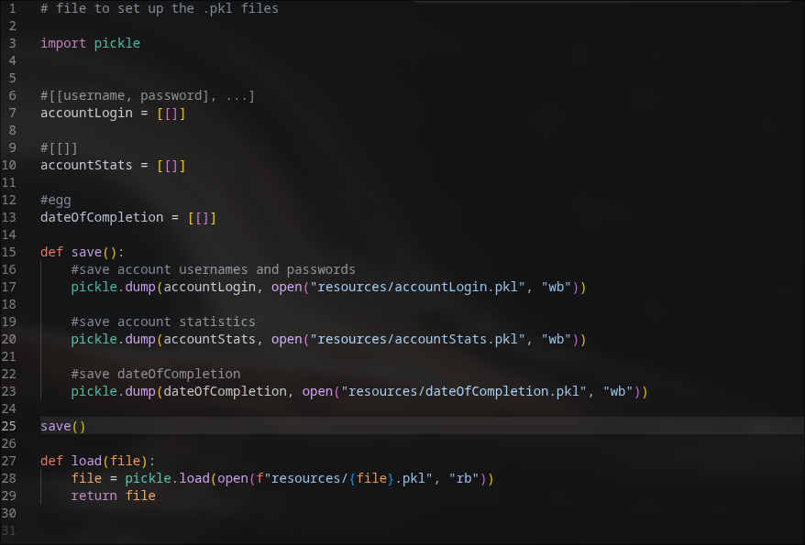

This new function creates takes two parameters: the error and the frame that the error occurred in. it then clears the frame and then inserts the error message and image. In order to return to the screen, the

